## ****Smart Drain Clearance System****

### ****By: Deiva Lakshmee****

### ****1. Abstract****

This mini-project proposes an innovative drainage management system that uses sensor-based monitoring and automation inspired by the city-wide piped gas system. Instead of manual tracking and complaint-based clearance, our system detects sewage tank threshold levels, notifies the centralized company (Smart Drain Clearance), and enables automated scheduling of lorry dispatch and payment via a secure web link. This is a complete end-to-end digital solution for effective drainage management.

### ****2. Problem Identification****

Drainage overflow and blockage cause serious hygiene and environmental issues. The current system is reactive, inefficient, and delayed. Citizens often face difficulty tracking fill levels and arranging lorry clearance. There's no centralized monitoring or automation in place.

### ****3. Objective****

* Automate the detection of drainage tank fill-levels.
* Notify the company when the threshold is reached.
* Auto-assign lorry dispatch and cleaning personnel.
* Send SMS to house owners with a secure bill payment link.
* Maintain payment records and employee salary disbursements.

### ****4. System Overview****

* **Sensors** (e.g., ultrasonic level detectors) are placed in household/sewage tanks.
* When the level crosses the threshold, data is sent to the **Smart Drain Clearance Company**.
* The system identifies the nearest lorry and available worker, schedules the clearance.
* Post-clearance, the customer receives an **SMS with a payment link**.
* Payment is done on the website; the system logs transaction and clears invoice.
* Worker payment is processed based on job count.

### ****5. Hardware & Software Requirements****

**🛠Hardware Requirements**

* Raspberry Pi (any model with GPIO support)
* Ultrasonic Sensor (HC-SR04)
* Jumper Wires
* Breadboard
* Power Supply
* 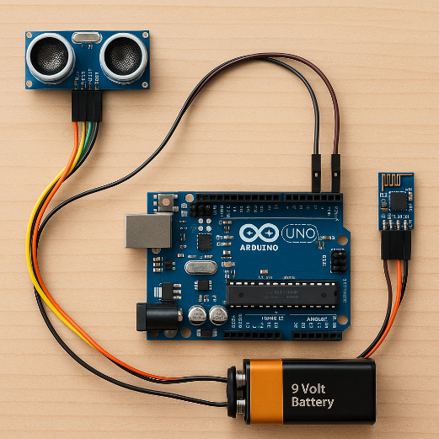Wi-Fi module (built-in for Pi 3/4)

**Ultrasonic sensor module**

**(with labels like VCC, TRIG, ECHO, GND)**

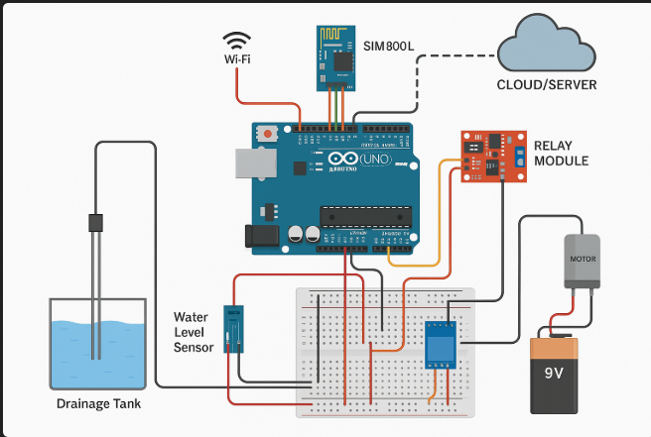

**A Raspberry Pi GPIO pinout diagram**

**These images show how an ultrasonic distance sensor is connected to a Raspberry Pi using GPIO pins. The TRIG pin sends sound pulses, and the ECHO pin receives them to measure the distance to an object.**

**💻 Software Requirements**

* Python 3
* Raspbian OS (for Raspberry Pi)
* GPIO Python Library (RPi.GPIO)
* Terminal or Python IDE (e.g., Thonny, VS Code)

### ****6. Architecture Diagram****

The diagram illustrates how sensors, customers, lorries, and payment flow interact under the Smart Drain Clearance system.

### 

### ****7. Sample Code Snippet****

### import RPi.GPIO as GPIO

### import time

### GPIO.setmode(GPIO.BCM)

### TRIG = 9

### ECHO = 10

### GPIO.setup(TRIG, GPIO.OUT)

### GPIO.setup(ECHO, GPIO.IN)

### def measure_distance():

### GPIO.output(TRIG, False)

### time.sleep(2)

### GPIO.output(TRIG, True)

### time.sleep(0.00001)

### GPIO.output(TRIG, False)

### while GPIO.input(ECHO) == 0:

### pulse_start = time.time()

### while GPIO.input(ECHO) == 1:

### pulse_end = time.time()

### pulse_duration = pulse_end - pulse_start

### distance = pulse_duration * 17150

### distance = round(distance, 2)

### return distance

### try:

### while True:

### dist = measure_distance()

### print("Distance:", dist, "cm")

### if dist < 10:

### print("Drainage block detected! Overflow risk!")

### time.sleep(5)

### except KeyboardInterrupt:

### GPIO.cleanup()

### ****8. Workflow (Step by Step)****

1. Tank sensor monitors the sewage level.
2. If threshold crossed, system sends data to company server.
3. Server maps nearest lorry + worker → auto-assigns job.
4. Job done → SMS to owner with bill link.
5. Owner pays online → system updates record.
6. Worker’s wallet updated based on clearance count.

### ****9. Features****

* Real-time drainage monitoring
* Instant company notification system
* Auto-payment through SMS billing
* Web dashboard for admin, customer, and worker
* Scalable for municipal/city-wide use

### ****10. Advantages****

* Zero manual monitoring
* No customer complaint required
* Efficient worker management
* Transparent payment flow
* Pollution & health issues minimized

### ****11. Future Scope****

* AI integration to predict tank fill trends
* Map-based lorry movement tracker
* Predictive maintenance alerts
* Government-linked urban drainage upgrade model
* Voice-based or app-based customer service
* Cost analysis dashboard
* Risk management features (alert on sensor damage, etc.)

### ****12. Challenges & Solutions****

| **Challenge** | **Proposed Solution** |
| --- | --- |
| Network instability in remote areas | Use GSM + LoRa for data redundancy |
| Lorry scheduling overlaps | Auto-scheduler with priority matrix |
| Sensor inaccuracy due to waste layers | Calibration + redundant sensors per tank |
| Payment failure due to broken links | OTP-based secure payment retries |

### ****13. Conclusion****

This project redefines sewage management in a smart, scalable way. It automates not just detection but also action—making urban living cleaner, safer, and more convenient. Inspired by gasline systems, Smart Drain Clearance bridges the gap between technology and sanitation.